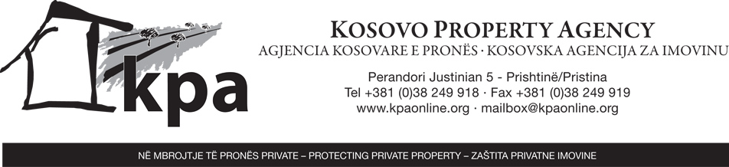

APPLICATION FORM FOR TRANSLATION ASSISTANCE OF DOCUMENTATION SUBMITTED AS PART OF A CLAIM REGISTERED WITH THE KOSOVO PROPERTY AGENCY

PERSONAL DETAILS OF APPLICANT

First Name: | Family Name:
Address:

Municipality:

District:

Telephone Number:

Other contact information:

Gender: Male: Female:
Marital Status: Single: Married: Separated: Divorced: Widowed:
No. of dependant children (including ages):

Profession:

KPA Claim Number(s):
Language you would like the documentation translated into: (please select only one)
Albanian: English: Serbian:

N.B. If you are applying on behalf of a claimant and have not already provided a power of attorney you must provide a copy of this and a copy of the claimants I.D. card with the application form.

FINANCIAL DETAILS OF APPLICANT

Monthly salary:  Income from property or other sources:  Savings:  Other income: |  |  | No income  Unemployed  Social assistance:  Pension:
FINANCIAL DETAILS OF MEMBERS OF HOUSEHOLD

Name | Date of Birth | Relationship |  | Total Monthly Income (all sources) | Profession
Total monthly household income:

Estimate of monthly household expenses (please list):

List of documents enclosed in support of your request:

Why is your household income not sufficient to cover the cost of translations after payment of reasonable household expenses? Reasons:

APPLICANT’S DECLARATION

I declare that the information and documentation I have provided in support of this application are true and correct.

I understand that my entitlement to translation assistance may be terminated if I am found to have provided false information and that the Executive Secretariat of the Kosovo Property Agency - in the following referred to as the KPA - may seek to recover from me any costs incurred in the preparation or provision of any translation services.

I understand that the KPA may request further information and documentation in order to confirm my entitlement to translation assistance and hereby authorize the KPA to make enquiries of any government, non-governmental agencies or financial institutions for this purpose. I understand that if I am not able to provide such information to substantiate my financial situation, or do not authorize the KPA to obtain this information, including from financial institutions and other non-government agencies, my request for translation assistance may be refused.

I understand that I must inform the KPA immediately of any change in my circumstances that would affect my entitlement to receive translation assistance.

I understand and accept that the KPA will provide non-court accredited translation of those documents that are deemed material to the claim(s) as listed above. I accept that it is my decision to determine whether a court-accredited translation of any of the documents submitted in support of the claim(s) is/are required in order to address the legal basis of the claim and for any further information that I may decide to provide to the KPA. I further agree to obtain any such court-accredited translation at my own cost and from a source of my own choosing outside of the KPA.

I understand that if approved only “key documents”, potentially having an impact on the decision, will be translated. What constitutes such “key documents” is to be decided by the KPA.

I confirm that I will not hold the KPA liable for any act of omission or error in the provision of the non-court-accredited translation how so ever caused.

Signed:

Date:

Please submit the fully completed application form to any KPA Office in Kosovo or Montenegro or to any UNHCR Property Office in Serbia.

